UNIT 1

1>compare direct and indirect imaging, with block diagram explain Biomedical image processing and its applications.

Soln:

Direct and indirect imaging:

Biomedical image processing is a technique of extracting required data from the captured images in the medical field.

It includes the analysis, enhancement and display of images captured via x-ray, ultrasound, MRI, nuclear medicine and optical imaging technologies.  
Image reconstruction and modelling techniques allow instant processing of 2D signals to create 3D images.

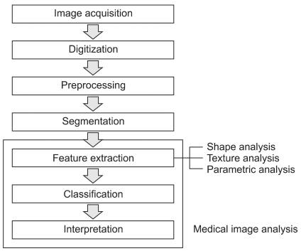

Here are some specific Applications:

– Automatic detection of tumors, characterizing their types,

– Measurement of normal/abnormal structures,

– Visualization of anatomy, surgery guidance, therapy planning,

– Exploring relationship between clinical, genomic, and imaging based markers.

2>what is electromagnetic spectrum elaborate its application in biomedical image processing.

When all the electromagnetic radiations are arranged in order of increasing wavelengths, and decreasing frequencies the complete spectrum is called electromagnetic spectrum

Radio waves in MRI:

* Used to produce images of soft tissues, fluid, fat and bone.
* Does this by producing a map which depends on the density of hydrogen in the body.
* When a person is lying in the magnetic field of the MRI scanner the hydrogen atoms in their body line up.
* An radiofrequency field is applied, which causes some of the protons to flip around and the atoms spin together.
* This in turn produces a change in magnetic field, which induces a voltage in a coil, and the signal is used to produce an image, dependent upon the tightness of the protons.

3>what is resolution? Emphasize different resolution in biomedical.

Resolution is **a measure used to describe the sharpness and clarity of an image or picture**

4>explain sampling and quantization.

In Digital Image Processing, signals captured from the physical world need to be translated into digital form by “Digitization” Process. In order to become suitable for digital processing, an image function f(x,y) must be digitized both spatially and in amplitude.

Digitization process involves two main processes called

1. **Sampling:** Digitizing the co-ordinate value is called sampling.
2. **Quantization:** Digitizing the amplitude value is called quantization

SAMPLING:

Since an analogue image is continuous not just in its co-ordinates (x axis), but also in its amplitude (y axis), so the part that deals with the digitizing of co-ordinates is known as sampling. In digitizing sampling is done on independent variable. In case of equation y = sin(x), it is done on x variable.

https://miro.medium.com/max/60/0*nwDgS4-PA4QRZD7t.jpg?q=20

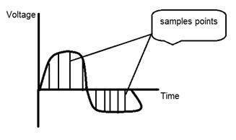

When looking at this image, we can see there are some random variations in the signal caused by noise. In sampling we reduce this noise by taking samples. It is obvious that more samples we take, the quality of the image would be more better, the noise would be more removed and same happens vice versa. However, if you take sampling on the x axis, the signal is not converted to digital format, unless you take sampling of the y-axis too which is known as quantization.

Quantization

It is opposite to sampling because it is done on “y axis” while sampling is done on “x axis”. Quantization is a process of transforming a real valued sampled image to one taking only a finite number of distinct values. Under quantization process the amplitude values of the image are digitized. In simple words, when you are quantizing an image, you are actually dividing a signal into quanta(partitions).

5>list different biomedical image Modalities and compare its advantages and disadvantages.

6>explain image transforms.

An [image transform](https://www.mathworks.com/discovery/image-transform.html) can be applied to an image to convert it from one domain to another. Viewing an image in domains such as frequency or [Hough space](https://www.mathworks.com/help/images/ref/hough.html) enables the identification of features that may not be as easily detected in the spatial domain. Common image transforms include:

* [Hough Transform](https://www.mathworks.com/help/images/object-analysis.html#f11-27827), used to find lines in an image
* [Radon Transform](https://www.mathworks.com/help/images/reconstructing-an-image-from-projection-data.html), used to reconstruct images from fan-beam and parallel-beam projection data
* [Discrete Cosine Transform](https://www.mathworks.com/help/images/discrete-cosine-transform.html), used in image and video compression
* [Discrete Fourier Transform](https://www.mathworks.com/help/images/fourier-transform.html), used in filtering and frequency analysis
* [Wavelet Transform](https://www.mathworks.com/help/wavelet/ref/dwt2.html), used to perform discrete wavelet analysis, denoise, and fuse images

7>with relevant equations explain DCT, DWT, Transforms.

DCT: [https://www.mathworks.in/help/images/discrete-cosine-transform.html#:~:text=The%20discrete%20cosine%20transform%20(DCT,of%20varying%20magnitudes%20and%20frequencies.&text=For%20this%20reason%2C%20the%20DCT,compression%20algorithm%20known%20as%20JPEG.](https://www.mathworks.in/help/images/discrete-cosine-transform.html%23:~:text=The%20discrete%20cosine%20transform%20(DCT,of%20varying%20magnitudes%20and%20frequencies.&text=For%20this%20reason%2C%20the%20DCT,compression%20algorithm%20known%20as%20JPEG.)

DWT

DWT is a wavelet transform for which the wavelets are sampled at discrete intervals. DWT provides a simultaneous spatial and frequency domain information of the image. In DWT operation, an image can be analyzed by the combination of analysis filter bank and decimation operation. The analysis filter bank consists of a pair of low and high pass filters corresponding to each decomposition level. The low pass filter extracts the approximate information of the image whereas the high pass filter extracts the details such as edges. The 2D transform is obtained from two separate 1D transforms. In 1D DWT, the approximation coefficients contain low frequency information whereas the detail coefficients contain high frequency information. The application of 2D DWT decomposes the input image into four separate sub bands (R.C. Gonzalez & R. E. Woods 2008): low frequency components in horizontal and vertical directions (cA), low frequency component in the horizontal and high frequency component in the vertical direction (cV), high frequency component in the horizontal and low frequency component in the vertical direction (cH) and high frequency components in horizontal and vertical directions (cD). cA, cV, cH and cD can also be represented as LL, LH, HL and HH respectively. The representation of an image I after 1-level DWT with its sub-bands is given by the Eq. 2 (E. Gumus 2010).

I = I 1 a + I 1 h +I 1 v +I 1 d (2)

where I1 a represents the approximation of input image (smaller scaled form) and I1 h , I1 v , I1 d represent horizontal, vertical and diagonal details respectively, where the powers of the terms represent the level of decomposition.

8>Compare super Resolution and image fusion in biomedical image processing.

9>compare image enhancement and image restoration.

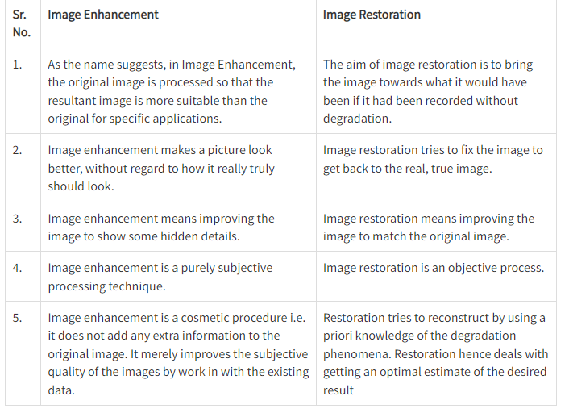

10>explain how image transforms can be used for data compression and feature extraction.

11>explain image fusion with two different modalities.

12>review on super resolution, image fusion, image transforms.

13>Explain frontier of image processing in medical.

14> explain pixel neighbours, adjacency and distance measure with relevant equations and diagrams.

<http://www.cse.iitm.ac.in/~vplab/courses/CV_DIP/PDF/NEIGH_CONN.pdf>